***Changing an Object’s colour on player input***

***Goal:***

To create a script the changes the colour of a game object then the players press a key (Example spacebar)

1. Create a new unity project, you can start by creating a new 3D project

. 

1. Go to the top menu and click GameObject and 3D Object and then Sphere. Name the sphere "ColorChanger" in the Hierarchy. Reset the sphere's position by right-clicking Transform Reset in the Inspector.

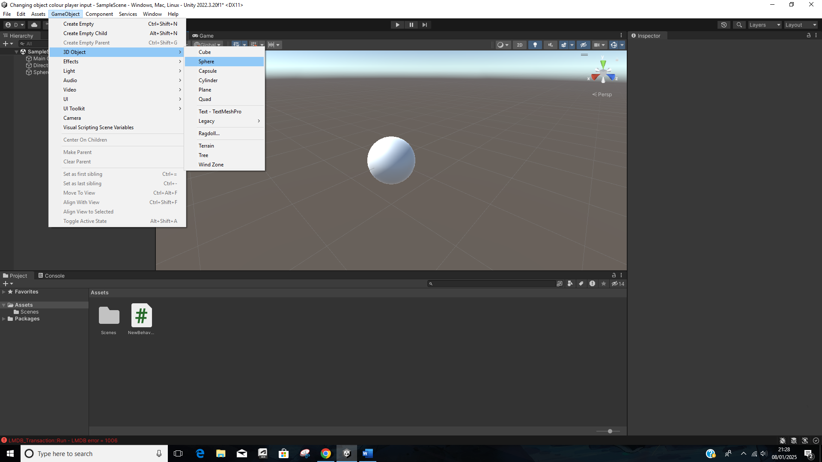

1. In the Assets folder, right-click and select Create C# Script. Name the script ColorChanger. Drag and drop the script onto the "ColorChanger" in the Hierarchy.
2. **Script explanation**

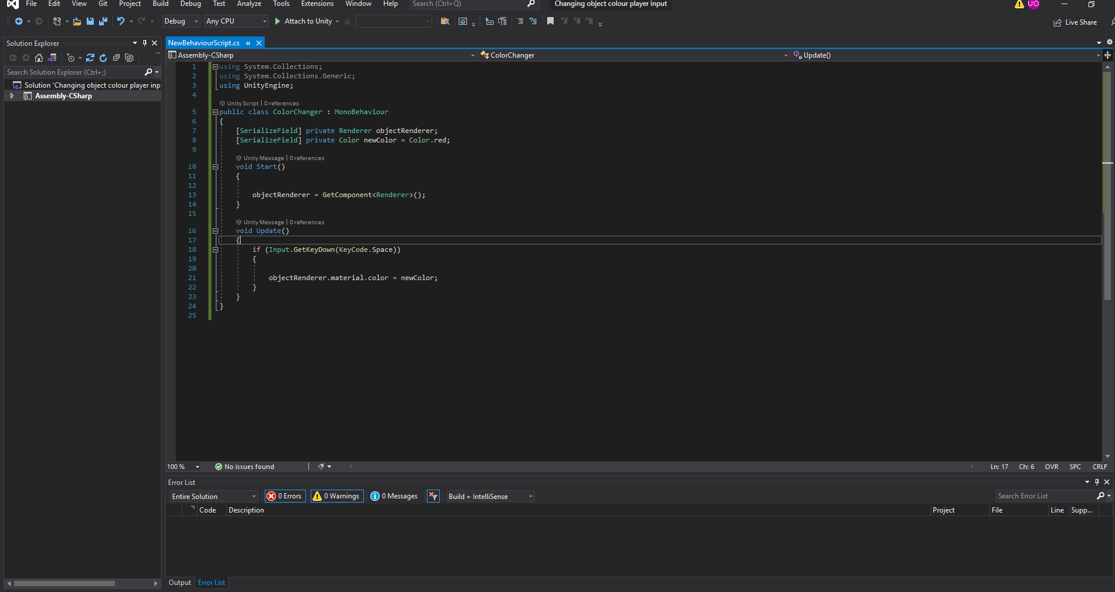

* using System.Collections using System.Collections.Generic using UnityEngine; This is standard unity libraries for handling game objects and input
* public class colorChanger : MonoBheaviour This the class name matches the script name and is derived from MonoBehaviour.
* [SerializeField] This allws you to set variables in the Unity Inspector.
* objectRenderer This will reference the object’s Renderer component, which controls its appearance.
* newColor This is the color the object will change to when the player presses the spacebar.
* GetComponenet<Renderer> () Retrieves the Renderer componene tattacted the object this ensures the script knows which object to change the color of.
* Input.GetKeyDown(KeyCode.space) Checks if the spacebar was pressed.
* objectRenderer.material.color=newColor.

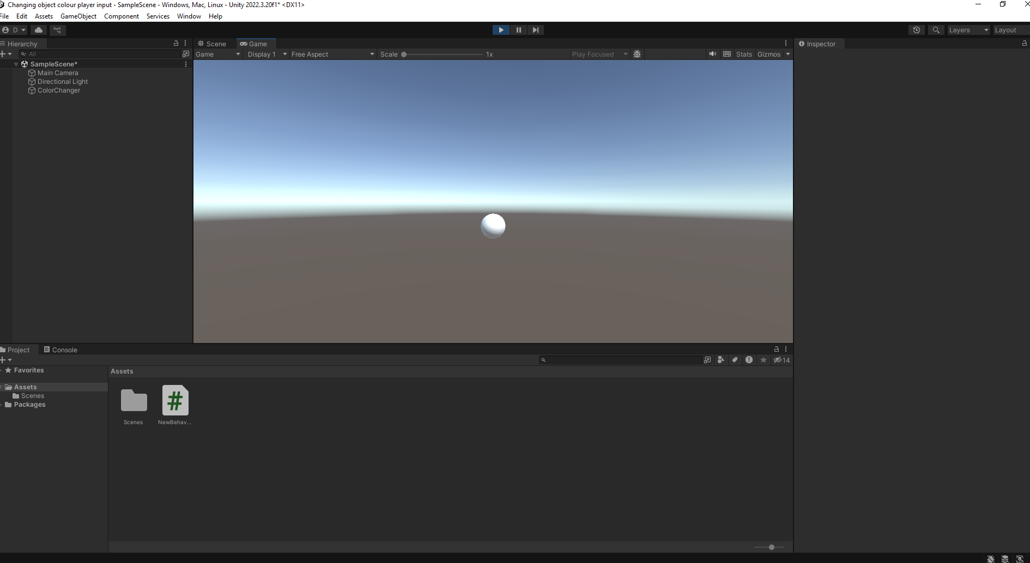

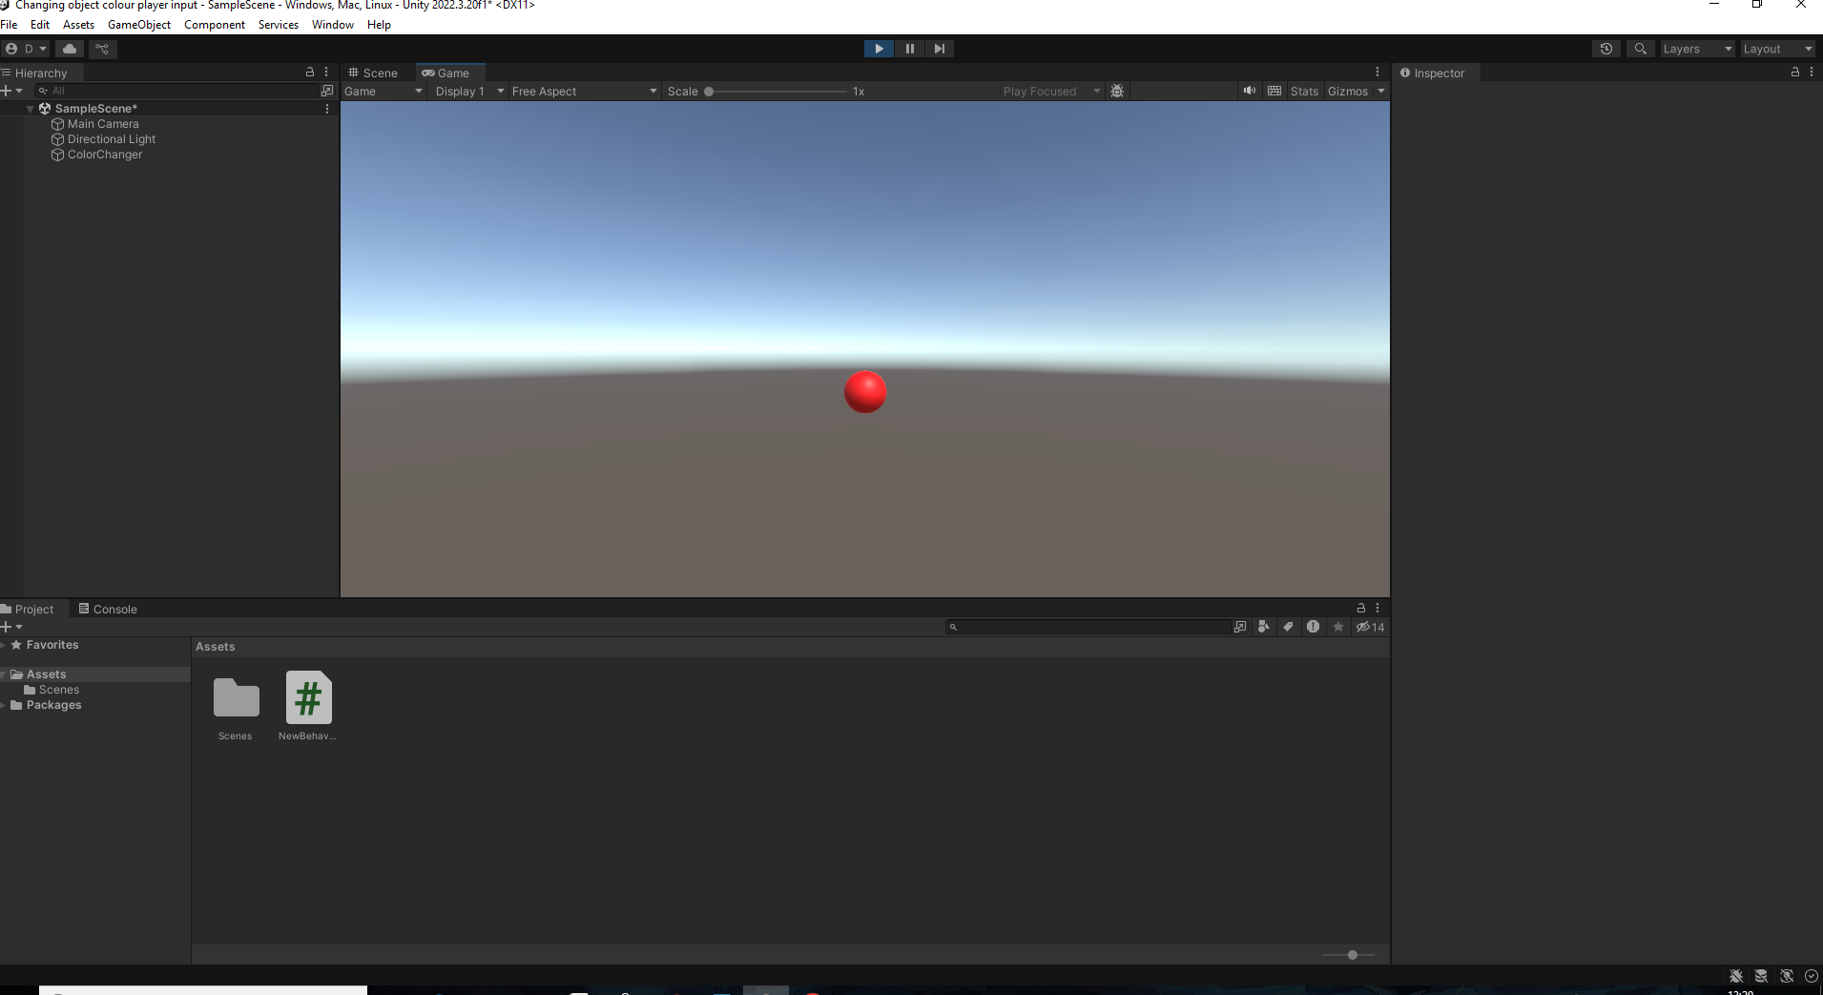

Save the script in your code editor, and then go back to unity and press play and press the spacebar to see the object change in my case I chose red.